[ Insert official UPAEP logo ]
UPAEP · Decanato de Ingenierías
EVIDENCE — US16-T6
Run the closed-loop irrigation simulation
SmartGreenAI: Cilantro Crop

1. Task information
Task ID | US16-T6
User Story | US-16 — Automatic irrigation according to predefined conditions
Sprint | Sprint 3 (2026-10-12 – 2026-10-30)
Week | Week 3
Responsible | Oscar Abraham Talavera Nava
Peer reviewer | Vicente Rocha Alfaro
Planned / actual hours | 1.5 h / 1.5 h
Completed on | October 29, 2026
Status | Done

2. Task description
Extend the simulator so soil moisture rises while the pump is ON and falls by evaporation, run an accelerated 2-hour scenario and plot soil moisture against pump state.

3. Completion conditions
✓ Condition 1: Simulator reacts to the pump state.
How it was verified: The simulator reacts to the pump: while ACT-PUMP-01 is ON the soil moisture rises 1.1 %/simulated minute; otherwise it falls by evaporation, faster when it is hot and dry (scenario "dry" doubles it).
iot/simulator/simulator.js — lines 106–141
function step(minutes) {
env.simTime += minutes * 60000;
const localHour = (new Date(env.simTime).getUTCHours() - 6 + 24) % 24;
const daylight = Math.max(0, Math.sin(((localHour - 6) / 13) * Math.PI));
// Temperature: scenario baseline + gentle day cycle; the fan cools.
const base = OPTS.scenario === 'hot' || OPTS.scenario === 'acceptance' ? 28.5 : 19 + 5 * daylight;
env.temperature += (base - env.temperature) * 0.05 * minutes + noise(0.15);
if (actuators['ACT-FAN-01'].state === 'ON') env.temperature -= 0.08 * minutes;
if (actuators['ACT-SHADE-01'].state === 'ON') env.temperature -= 0.03 * minutes;
env.humidity = clamp(env.humidity + ((78 - (env.temperature - 17) * 2.6) - env.humidity) * 0.05 * minutes + noise(0.5), 30, 95);
env.light = daylight > 0 ? clamp(daylight * 30000 + noise(1200), 0, 90000) : 0;
if (actuators['ACT-LIGHT-01'].state === 'ON') env.light += 8000;
if (actuators['ACT-SHADE-01'].state === 'ON') env.light *= 0.6;
env.co2 = clamp(820 - daylight * 360 + noise(20), 380, 1400);
// Soil water balance: evaporation grows with heat and dry air.
const evaporation = 0.007 + Math.max(0, env.temperature - 18) * 0.0018 + Math.max(0, 60 - env.humidity) * 0.0004;
env.moisture -= evaporation * minutes * (OPTS.scenario === 'dry' ? 2 : 1);
if (actuators['ACT-PUMP-01'].state === 'ON' && env.tank > 0) {
env.moisture += 1.1 * minutes;
env.tank = Math.max(0, env.tank - 0.1 * minutes);
}
env.moisture = clamp(env.moisture, 20, 95);
env.ph = clamp(env.ph + noise(0.01) + (6.5 - env.ph) * 0.02, 6.0, 7.0);
// Auto-OFF of timed commands (the firmware does the same with millis()).
for (const [id, a] of Object.entries(actuators)) {
if (a.state === 'ON' && a.offAt && env.simTime >= a.offAt) {
a.state = 'OFF';
a.offAt = null;
… (4 more lines)

✓ Condition 2: Scenario run for at least 2 simulated hours.
How it was verified: The scenario ran for 119 simulated minutes (48 cycles, speed ×30) against the live API with the automatic engine in AUTOMATIC mode; the engine started the pump 1 time(s). For the accelerated run the cooldown was set to 1 real minute (≈ 30 simulated minutes) and restored to 30 minutes afterwards.
Simulator log (excerpt) (attached: US16-T6_Run_Closed-Loop_Irrigation_Simulation_1.log)
SmartGreenAI simulator · scenario "dry" · every 5 s · speed x30 · API http://localhost:3000/api
22:50:35 → 8/8 readings stored in 80 ms | soil 54.5 % soil 2 53.4 % temp 22 °C hum 60 % tank 85 % | 2 new alert(s)
22:50:40 → 8/8 readings stored in 70 ms | soil 54.9 % soil 2 53.4 % temp 22.1 °C hum 60.1 % tank 85 %
22:50:45 → 8/8 readings stored in 59 ms | soil 54.4 % soil 2 53.7 % temp 22.4 °C hum 61.3 % tank 85 %
22:50:50 → 8/8 readings stored in 56 ms | soil 55.1 % soil 2 53.6 % temp 22.6 °C hum 60.8 % tank 85 %
22:50:55 → 8/8 readings stored in 72 ms | soil 55.1 % soil 2 54.1 % temp 22.9 °C hum 60.9 % tank 85 %
22:51:01 → 8/8 readings stored in 60 ms | soil 54.6 % soil 2 54.2 % temp 22.8 °C hum 60.9 % tank 85 %
22:51:06 → 8/8 readings stored in 58 ms | soil 54.9 % soil 2 53.3 % temp 22.5 °C hum 61 % tank 85 %
22:51:11 → 8/8 readings stored in 59 ms | soil 54 % soil 2 53.4 % temp 22.4 °C hum 61.1 % tank 85 %
22:51:16 → 8/8 readings stored in 68 ms | soil 54.5 % soil 2 53 % temp 22.2 °C hum 60 % tank 85 %
22:51:21 → 8/8 readings stored in 59 ms | soil 54.7 % soil 2 53.9 % temp 22.1 °C hum 60.6 % tank 85 %
22:51:26 → 8/8 readings stored in 64 ms | soil 54.3 % soil 2 53.5 % temp 22.1 °C hum 60.6 % tank 85 %
22:51:31 → 8/8 readings stored in 63 ms | soil 54.1 % soil 2 53.4 % temp 22.1 °C hum 60.1 % tank 85 %
22:51:31 ⏻ command cmd-2a16df59a9d1: ACT-PUMP-01 ON for 10 min (source AUTOMATIC)
22:51:36 → 8/8 readings stored in 78 ms | soil 57 % soil 2 55.5 % temp 22.3 °C hum 60.8 % tank 84.7 %
22:51:41 → 8/8 readings stored in 68 ms | soil 59.7 % soil 2 58 % temp 22.1 °C hum 60.7 % tank 84.5 %
22:51:46 → 8/8 readings stored in 80 ms | soil 62.7 % soil 2 61.4 % temp 22.1 °C hum 61.4 % tank 84.2 %
22:51:51 ⏹ ACT-PUMP-01 OFF (duration elapsed)
22:51:51 → 8/8 readings stored in 50 ms | soil 64.5 % soil 2 63.6 % temp 22 °C hum 61.8 % tank 84 %
22:51:56 → 8/8 readings stored in 54 ms | soil 64.7 % soil 2 64.1 % temp 21.8 °C hum 62.2 % tank 84 %
22:52:01 → 8/8 readings stored in 62 ms | soil 64.5 % soil 2 63.7 % temp 21.8 °C hum 63.9 % tank 84 % | anomalies: ZSCORE
22:52:06 → 8/8 readings stored in 57 ms | soil 64.6 % soil 2 63.9 % temp 21.5 °C hum 65.1 % tank 84 % | anomalies: ZSCORE
22:52:12 → 8/8 readings stored in 55 ms | soil 64.5 % soil 2 63.8 % temp 21.6 °C hum 65.1 % tank 84 %
22:52:17 → 8/8 readings stored in 62 ms | soil 64.4 % soil 2 63.4 % temp 21.4 °C hum 64.7 % tank 84 %
22:52:22 → 8/8 readings stored in 57 ms | soil 64.6 % soil 2 63.4 % temp 21.4 °C hum 64.2 % tank 84 %
22:52:27 → 8/8 readings stored in 53 ms | soil 64.3 % soil 2 64.1 % temp 21.3 °C hum 63.5 % tank 84 %
22:52:32 → 8/8 readings stored in 55 ms | soil 64 % soil 2 63 % temp 21.1 °C hum 63.7 % tank 84 %
22:52:37 → 8/8 readings stored in 52 ms | soil 64.9 % soil 2 63.6 % temp 21.1 °C hum 64.2 % tank 84 %
22:52:42 → 8/8 readings stored in 64 ms | soil 64.2 % soil 2 62.8 % temp 21.1 °C hum 64.1 % tank 84 %
22:52:47 → 8/8 readings stored in 54 ms | soil 64.2 % soil 2 62.7 % temp 20.9 °C hum 64.8 % tank 84 %
22:52:52 → 8/8 readings stored in 57 ms | soil 64.5 % soil 2 63.2 % temp 21 °C hum 64.9 % tank 84 %
22:52:57 → 8/8 readings stored in 76 ms | soil 63.8 % soil 2 63.1 % temp 20.7 °C hum 64.7 % tank 84 % | 1 new alert(s)
22:53:02 ⏻ command cmd-164b02b71a11: ACT-LIGHT-01 ON (source AUTOMATIC)
22:53:02 → 8/8 readings stored in 59 ms | soil 64.3 % soil 2 62.9 % temp 20.8 °C hum 64.9 % tank 84 %
22:53:07 → 8/8 readings stored in 53 ms | soil 64.4 % soil 2 62.5 % temp 20.6 °C hum 65.7 % tank 84 %
22:53:12 → 8/8 readings stored in 51 ms | soil 63.8 % soil 2 63.4 % temp 20.8 °C hum 66.7 % tank 84 %
22:53:17 → 8/8 readings stored in 49 ms | soil 64.1 % soil 2 63.5 % temp 20.9 °C hum 66.7 % tank 84 %
22:53:22 → 8/8 readings stored in 52 ms | soil 64.2 % soil 2 62.6 % temp 21.1 °C hum 66 % tank 84 %
22:53:27 → 8/8 readings stored in 60 ms | soil 63.8 % soil 2 62.2 % temp 21.1 °C hum 66.8 % tank 84 %
22:53:32 ⏻ command cmd-ae33ced4ad5a: ACT-LIGHT-01 OFF (source AUTOMATIC)

✓ Condition 3: Chart generated.
How it was verified: Chart generated from the CSV written by the simulator.
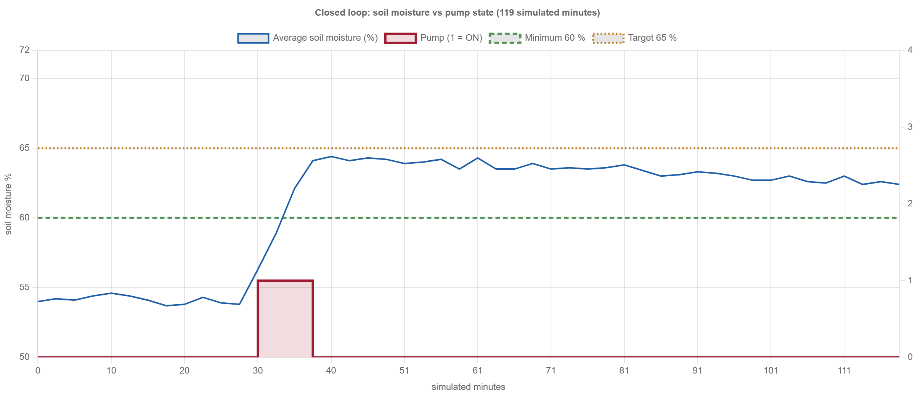
Figure US16-T6-1. Soil moisture against the pump state in the closed-loop simulation (data: attached CSV). (US16-T6_Run_Closed-Loop_Irrigation_Simulation_3.png)
✓ Condition 4: Evidence: Chart of soil moisture vs pump state and simulator log.
How it was verified: Chart of soil moisture vs pump state and simulator log (US16-T6_Run_Closed-Loop_Irrigation_Simulation_2.csv, US16-T6_Run_Closed-Loop_Irrigation_Simulation_1.log).

4. Attached files
- US16-T6_Run_Closed-Loop_Irrigation_Simulation_1.log
- US16-T6_Run_Closed-Loop_Irrigation_Simulation_2.csv
- US16-T6_Run_Closed-Loop_Irrigation_Simulation_3.png

5. Traceability
Related requirements | FR-18, NFR-08
Implementation | simulator step() physics (pump +1.1 %/min, evaporation by temperature/humidity), --speed, --csv
Verification | node iot/simulator/simulator.js --scenario dry --speed 60 --interval 5 --csv loop.csv

6. Sign-off
Role | Name | Date | Signature
Responsible | Oscar Abraham Talavera Nava | October 29, 2026
Peer reviewer | Vicente Rocha Alfaro | October 29, 2026
Product Owner acceptance | Alexis Enrique Valle Parra | October 29, 2026
Approval record: Sprint 3 Review & Delivery (October 30, 2026): "Product Owner accepted the seven user stories: all acceptance criteria met."

